Practical activity: Methane Bubbles Demonstration
Demonstration Guide – Methane Bubbles

Aim: To demonstrate the flammability of methane gas
Notes and guidance
For many years and in many schools, this demonstration has been carried out with the involvement of students. CLEAPSS now advise strongly against this. Please see the risk assessment notes below, consult CLEAPSS if you have any questions about carrying out this practical safely.

This demonstration may not have as much obvious educational value as other practicals in the Science Mastery curriculum, but it is always incredibly engaging for students. You may wish to carry this out towards the start of the year or whenever students need to be reminded how exciting practical science can be.
Risk Assessment Notes
A risk assessment must be completed for this practical. The risk assessment should be specific to the class involved and written only by the teaching member of staff. For more guidance refer to CLEAPSS. It is good practice for students to wear safety spectacles during all class practicals and demos.

A second adult is required for this demonstration alongside the class teacher. Both adults should trial this demonstration before attempting it in front of a class. Hair must be tied back and hands/arms wet with soap. Students must stand a safe distance from the demonstration area wearing eye protection. Reliable students may ignite the methane bubbles if the teacher risk assesses this.

Ensure the laboratory is well-ventilated and has sufficient space – bubbles must not be ignited within 1 m of the ceiling. Remove any paper mobiles or displays from the demonstration area. Use no other gas but methane from the lab’s mains supply. Do not pile bubbles > 10 cm high.

Any deviation from the CLEAPSS risk assessment must be cleared with CLEAPSS, your Head of Department, and your technician colleagues.
Equipment | Equipment Setup  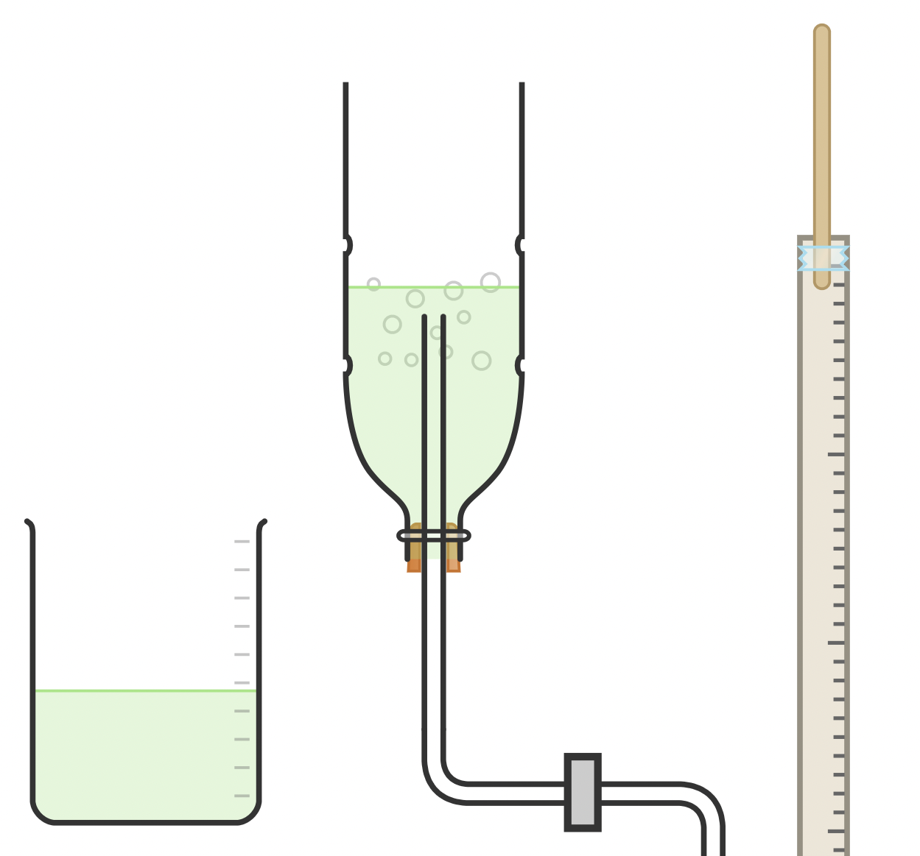
Apparatus:
- Wooden splints
- Tape (or bulldog clip)
- Metre ruler
- 500 ml bottle with end cut off
- Large beaker
- Single-hole bung for bottle
- Delivery tube to connect to mains
- Hoffman tube clip
- Retort stand
- Clamp
- Bunsen Burner
- Heat proof mat

Chemicals:
- Methane from mains supple only (do not use any other hydrocarbon cases)
- Bubble mixture (85 parts water, ten parts liquid washing detergent, five parts glycerol)

Method |  | Questions To Ask Students During The Practical
- Insert the bung and delivery tube into the upturned bottle. Clamp to the stand upturned as per the diagram and connect the Hoffman tube clip to the delivery tube and the delivery tube to the mains gas supply.  - Make up the bubble mixture in the large beaker.  - Attach a splint to the end of a metre ruler using tape or a bulldog clip.  - Light a Bunsen burner approximately two metres away from the bubbles setup and have your trained adult assistant stand here with the metre ruler/splint.  - Pour bubble mixture into the upturned bottle so the delivery tube is just below the surface.  - Use the mains gas tap and Hoffman tube clip to allow gas to slowly bubble into the mixture.  - Remove an approximately 10 cm tall stack of bubbles by hand or with a small ruler.  - Demonstrate how the first crop of bubbles sink and subsequent bubbles float.  - Have your trained adult assistant light their splint.  - Standing a good distance away from the bubble source, allow an approximately 10 cm stack of bubbles to float into the air.  - When your assistant lights the bubbles, they form a fireball.  - If you have thoroughly risk-assessed, you may wish for a reliable student to light the bubbles.  - Wet your hands and arms thoroughly and ensure you have no loose-fitting clothing and long hair is tied back etc.  - Hold a small pile of bubbles (< 10 cm high) in your hands, a safe distance away from the bubble source, and outstretched, far away from your face.  - Have your trained adult assistant light the bubbles.  - Step back as the bubbles ignite. |  | - Why do the first few bubbles generated sink? (They contain air from the pipes, meaning the combined weight of the bubble mixture and the air is greater than the pure air around them.)  - Why do the subsequent bubble float? (They contain methane, which is lighter than air.)  - Why don’t we ignite the bubbles closer to the bubble source. (To avoid the fireball spreading to the large collection of bubbles at the source and potentially even the gas mains.)  - Why don’t we use more than a 10 cm high stack of bubbles? (The fireball would be dangerously big and may contact the demonstrator or lab furniture.)  - Why does the demonstrator thoroughly wet their hands and arms before igniting held bubbles? (To reduce the risk of a fireball singing them.)
Alternative Methods/Computer Simulations |  | Clearing up
Plenty of videos of this phenomenon are available online. You may wish to film a demonstration in your school to replay whenever the topic comes up. |  | It is important that equipment is returned to the prep room in good order. If safe to do so, rinse used equipment and put it in the used equipment tray. If the trays arrived on a trolley, students must return all trays and equipment to that trolley. Anything dirty needs to be placed into a separate container for washing up. Never put dirty equipment back into a tray with clean equipment.  Bubbles mixture can be diluted and poured down the sink with plenty of water. Equipment should be rinsed and all wet floors and surfaces around the demonstration area cleaned up with paper towels. Ensure the gas is switched off after the demonstration.
Technician Notes
Bubble mixture is 85 parts water, ten parts liquid washing detergent, five parts glycerol.

Discuss this practical with the class teacher ahead of time. Ensure they have considered the risks of this practical and are confident with the techniques used. If necessary, provide them with the CLEAPSS risk assessment.

Teachers and assistants must have rehearsed this demonstration before carrying it out.

If you have any H&S concerns about the way this demonstration is being carried out, discuss these with your HoD, your principal, and/or CLEAPSS.

